Supporting Documentation: Timed Automaton Analyzer
Ben Stone
CS6840
Dr. Brian Rague
August 12, 2025

(i) Problem Statement
This project is to develop a tool that analyzes timed automata. The program will parse a textual representation of an automaton, including its locations, clocks, and timing constraints. The core of the project is the implementation of the region construction algorithm, which translates the infinite-state timed automaton into an equivalent, finite-state region automaton. The tool will use Graphviz to generate a visual graph of the resulting region automaton, providing clear insight into the discrete state space of the real-time system. The program is implemented as a single Python script designed to be run from the command line, taking the path to a .txt automaton file as its input.

(ii) Code Modules
The program is contained within a single Python file: timedAutomatonAnalyzer.py. Its functionality is organized into several classes that act as modules for representing the system and executing the algorithm.

Location Class
Represents a single location (or state) within the timed automaton. Each Location object holds its name, its timing constraint (the invariant), and a flag indicating if it is the initial state of the system. It also pre-calculates the maximum integer constant from its invariant to aid the analysis algorithm.

Transition Class
Represents a transition (edge) between two locations in the timed automaton. A Transition object stores all the necessary information for an event to occur including the source and target locations, the guard condition, that must be true for the transition to be taken, the action label for the event, and a list of any clocks that are reset to zero when the transition occurs.

TimedAutomaton Class
Acts as a container for the entire timed automaton after it has been parsed from the input file. It holds dictionaries and lists of all the Location and Transition objects that define the system, as well as a direct reference to the initial location and the active clocks.

ClockZone Class
A crucial data structure that represents a symbolic constraint on a clock's value. Instead of tracking a specific numerical value, a ClockZone captures a condition, such as x = 5, 0 < x < 5, or x > 10. This class contains the logic for checking if a zone satisfies a transition's guard condition and for creating a new zone when a clock is reset.

Region Class
Represents a single node in the final output graph. A Region is a composite state defined by a pair: a Location from the original automaton and a ClockZone that specifies the state of the clock. The goal of the core algorithm is to find all reachable Region objects.

RegionAutomatonGenerator Class
This is the main engine of the program. It contains the implementation of the region construction algorithm. It takes a TimedAutomaton object as input and systematically explores its state space by processing a worklist of discovered regions. Its primary method, generate(), computes all reachable time successors and discrete successors to build a complete set of regions and the edges that connect them.

parse_txt_file() Function
A standalone function that serves as the system's parser. It reads the custom .txt file format, line by line, and instantiates the appropriate Location and Transition objects. It then assembles these into a single TimedAutomaton object that the rest of the program can use.

generate_dot_output() Function
A standalone function responsible for the final output. It takes the completed set of regions and edges from the RegionAutomatonGenerator and translates them into a string formatted in the Graphviz DOT language. This string is then saved to a .dot file, which can be rendered into a visual graph.
(iii) Illustrative Examples of Input/Output
The input is a text file representing the automaton, including its locations, clocks, and timing constraints.
The output is a DOT file representation of the Region Automaton that can be rendered into a visual graph.

Example 1 – Light Switch:
This system represents a simple light switch system that can be turned on, and will automatically turn off after 10 seconds, the initial state is off.
Input:
clock x

location Off {
initial
}

location On {
invariant x <= 10
}

transition {
source Off
target On
action press
reset x
}

transition {
source On
target Off
guard x == 10
action timeout
}

Output:
digraph RegionAutomaton {
rankdir=LR;
node [shape = box, style="rounded"];

// Node definitions
n0 [label="Off\n0<x<10"];
n1 [label="Off\nx=0"];
n2 [label="Off\nx=10"];
n3 [label="Off\nx>10"];
n4 [label="On\n0<x<10"];
n5 [label="On\nx=0"];
n6 [label="On\nx=10"];

// Starting arrow
start [shape=point, style=invis];
start -> n1;

// Edge definitions
n0 -> n2 [label="delay"];
n0 -> n5 [label="press"];
n1 -> n0 [label="delay"];
n1 -> n5 [label="press"];
n2 -> n3 [label="delay"];
n2 -> n5 [label="press"];
n3 -> n3 [label="delay"];
n3 -> n5 [label="press"];
n4 -> n6 [label="delay"];
n5 -> n4 [label="delay"];
n6 -> n2 [label="timeout"];
}

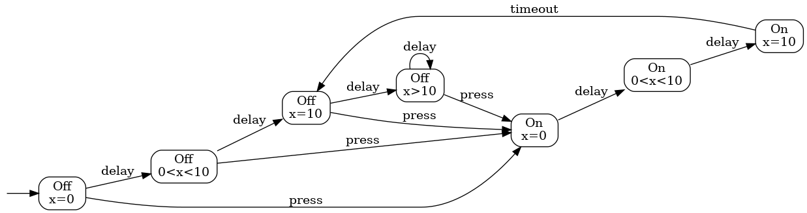
Example 2 – Traffic Light
This system represents a basic traffic light with red, yellow, and green lights, the light starts red and transitions in a circle from red, to green, to yellow. The light remains red for 60 seconds, green for 55 seconds and yellow for 5 seconds.
Input:
clock x

location Green {
invariant x <= 55
}

location Yellow {
invariant x <= 5
}

location Red {
initial
invariant x <= 60
}

transition {
source Green
target Yellow
guard x == 55
action prepare_to_stop
reset x
}

transition {
source Yellow
target Red
guard x == 5
action stop
reset x
}

transition {
source Red
target Green
guard x == 60
action go
reset x
}
Output:
digraph RegionAutomaton {
rankdir=LR;
node [shape = box, style="rounded"];

// Node definitions
n0 [label="Green\n0<x<55"];
n1 [label="Green\nx=0"];
n2 [label="Green\nx=55"];
n3 [label="Red\n0<x<60"];
n4 [label="Red\nx=0"];
n5 [label="Red\nx=60"];
n6 [label="Yellow\n0<x<5"];
n7 [label="Yellow\nx=0"];
n8 [label="Yellow\nx=5"];

// Starting arrow
start [shape=point, style=invis];
start -> n4;

// Edge definitions
n0 -> n2 [label="delay"];
n1 -> n0 [label="delay"];
n2 -> n7 [label="prepare_to_stop"];
n3 -> n5 [label="delay"];
n4 -> n3 [label="delay"];
n5 -> n1 [label="go"];
n6 -> n8 [label="delay"];
n7 -> n6 [label="delay"];
n8 -> n4 [label="stop"];
}

